Chapter Eleven
ARTIFICIAL INTELLIGENCE
Chapter Summary
This chapter begins by formulating research in artificial intelligence in the context of developing agents that exhibit rational (intelligent) behavior. It then proceeds to investigate the topics of perceiving and reasoning in the context of building an "intelligent" agent for solving the eight puzzle. Three additional areas in artificial intelligence, knowledge, learning and genetic algorithms, are explored in the Section 11.4, artificial neural networks are investigated in Section 11.5, and robotics is discussed in Section 11.6. The chapter closes by considering the social consequences of advances in artificial intelligence.
Comments
1. I think your students will be interested in the material on artificial neural networks. I tried to include enough to allow you to show how such networks are programmed and to explain some of the current research problems in the field. I find that students respond well to the material on associative memory.
2. A good example of a depth first search strategy is the approach to the problem of traversing a maze by staying next to the wall on your right until either the goal or a dead end is reached. (We'll assume that no loops can occur.) In the latter case one backtracks to the last possible choice that has not been tried, selects a new option at that point, and once again proceeds forward while staying against the wall on the right. This process is also a good instrument for demonstrating how a stack structure is embedded in the backtracking process.
3. The section on heuristic searching concludes with a brief explanation of the A*-algorithm. You may want to elaborate further in the classroom. Problems at the end of the section and at the end of the chapter provide insight into the A* algorithm. Map routing problems are used to demonstrate that the A* will find an optimal solution whereas the algorithm in the book does not find an optimal solution.
4. The eight-puzzle solving algorithm provides an example of how data structures can be extended from the traditional systems described in Chapter 8. In particular, a convenient technique for finding the "left-most leaf node with the smallest projected cost" is to link the leaf nodes together to form a linked list ordered by projected cost. Thus, each leaf node is in both a tree and a linked list. Depending on the emphasis you wish to place on data structures, the development of this structure might constitute the core of a meaningful class lecture that could be followed by the assignment of implementing the system.
5. This chapter is exceptionally suited to individual research projects using the Web as a source. If you’re looking for an assignment requiring a written report or a class presentation, this is a good opportunity.
Answers to Chapter Review Problems
1. "Would I tell on you?" might be used to reassure. "Do you see that snake?" might be a warning. "Can't you ever do anything right?" might be used to criticize.
2. The agent has two sensors: one detects money, the other detects the selection made. Its actuator is its dispensing mechanism. Its responses would be considered reflexive.
3. a. Knowledge based b. Reflex c. Goal based
4. No. A computer can memorize a list of names perfectly whereas a human cannot.
5. Knowing your name and address would be examples of declarative knowledge. Being able to tie your shoes is procedural knowledge.
6. Instance variables hold declarative knowledge. Methods hold procedural knowledge.
7. a. performance oriented
b. simulation oriented
c. performance oriented
d. simulation oriented
e. performance oriented
8. In recent years there have been improvements in automated answering system to support voice based conversation. However, the conversations are controlled by the automated system. They lack the ability to support general inquiry by the caller. Therefore, they still fall short of passing the Turing test. (The point here is for students to think about the Turing test and what it entails.)
9. A vertical bar with two horizontal bars, three horizontal, or one horizontal bar will distinguish an F from an E, and from either T or L respectively. Note, however, to distinguish between a T and an L further information on the placement of the horizontal bar in relation to the vertical bar is needed.
10. In both cases one selects the best match as being the correct interpretation of the input.
11. If the corner is concave, the drawing would be interpreted as a single large block with a corner cut out of it. If the corner is convex, the drawing would be interpreted as a small block floating in front of a larger block.
12. "By the barn" tells where and "by the farmer" tells how.
13. The parsing process would consider the two sentences as being completely different. For example, the subject in the first is sunset, while the subject in the second is Andrea. However, semantic analysis would recognize that the two sentences actually have the same meaning. Note in both cases the adjective awesome is correctly applied to the sunset.
14. The then and else clauses are different but the two sentences have the same meaning.
15. The question might be either a request for the time or a complaint that too much time has elapsed.
16. This is an example of how the meaning of a sentence can vary depending on its context. Here the significance of the action can vary from a simple act of childishness to one of abuse.
17. There should be entries for the people Donna, Jack, and the fielder, as well as the actions of hitting and catching associated with their correct objects and agents. Note that a problem surfaces as to how time relationships should be represented.
18. Database A could conclude that the employee did not belong to the company's health insurance program whereas database B could not.
19. The standard example is a database consisting of a single statement of the form "A or B." In this case the closed-world assumption leads to the contradictory conclusions ¬A and ¬B.
20. We normally apply the closed-world assumption when we deal with a list. If an item is not on the list, we assume that it is not supposed to be on the list, that is, we assume the list is complete. We also use the closed-world assumption when driving a car on the expressway—we assume that there is not construction around the bend unless we are told that there is.
21. The state graph is a representation of all possible states and paths, whereas the search tree represents only those states and paths under consideration.
22. The states are the various positions in which the cube may be. The productions are the various rotations that can be made. You are the control system.
23. a. There could be 2⁹ - 1 = 511 nodes in the tree when the goal is finally found.
b. Both search trees would contain at most 2⁵ - 1 = 31 nodes. Thus, the total number of nodes would be at most 62. (The point here is that the two trees would be half as deep as the single tree in part a, which significantly reduces the number of nodes considered.)
24. Students at this stage probably don't know the terminology of logical deduction or the predicate calculus, but I'm continually surprised by the quality of their own approaches to questions like this. The following is one approach to the problem using resolution. Let the predicates B, S, and T represent the predicates "is a basketball player," "is short," and "is tall," respectively. Then, each of the statements given in the problem can be expressed by clauses as follows:
B(John) = John is a basketball player
For all X, (¬S(X) OR ¬B(X)) = Basketball players are not short
T(John) OR S(John) = John is either tall or short
By universal specialization, the second clause can be modified to read ¬S(John) OR ¬B(John). Resolving this with the first clause gives ¬S(John), which resolves with the third clause to give T(John), representing the goal statement John is tall. Thus, the productions used are universal specialization and resolution.
25. Player X should select move B. This means that X cannot win but assures X of a tie. Note that following the production system examples in the text, one would be inclined to pick move A since this leads to leaf nodes that are most advantageous to X. However, Y will not allow X to reach these nodes. This is an example of the mini-max search strategy common in searching game trees.
26. States would be board configurations and productions would be checker moves. A (perhaps too) simple heuristic would be the number of the opponent’s checkers still on the board. Since this is a competitive game, the control system must compete with an adversary to move the system toward its goal. (You may want to show your students the mini-max process.)
27. Productions would include multiplying both sides of the equation by the same value, combining terms of similar type, and adding the same value to both sides of the equation. Heuristic rules would include moving all terms involving the variable for which the equation is being solved to the same side of the equation.
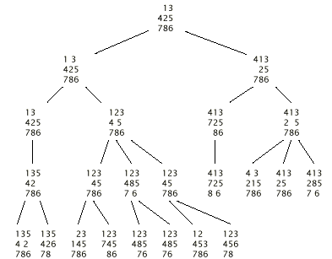
28.

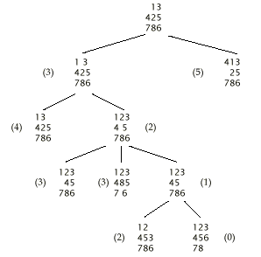
29.
30.
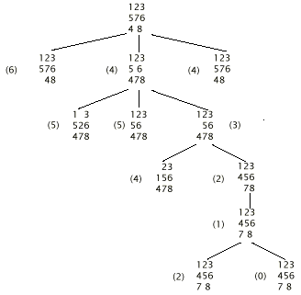
31. It does not distinguish between different states as well.
32. In the case of the binary search, there is no doubt as to which way to go, whereas in the case of searching for a goal state in a production system one can only guess which direction is correct.
33. As the state in question is revisited over and over, the cost accumulated in reaching it will grow larger and larger until the projected cost ultimately exceeds that of another option. At that point the control system will shift its attention to the other option. Thus, the algorithm will ultimately find its ways to the correct path.
34. One normally follows the road leading in the direction of the destination.
35.
Bath
8
Seaport
13
Trent
15
Avon
10
Avon
10
Seaport
13
Trent
15
Bath
8
Trent
15
The best fit algorithm, when driven solely by the heuristic of shortest straight line distance to the goal, will forever expand the nodes Bath and Avon. The goal state of Wildwood will never be reached. A modification to the best fit algorithm is to avoid adding nodes to the search tree for cities that are already present in the search tree. Then, when selecting a node for expansion, skip those that cannot be further expanded.
36.
Bath
7+8=15
Seaport
8+13
=21

Trent
0+15=15
Avon
8+10=18
Seaport
16+13
=29
Avon
13+10
=23
Trent
14+15
=29
Bath
17+18
=25
Trent
16+15
=31
Wildwood
22+0=22
Bath
14+8
=22
Trent
16+15
=31
The found path is Trent to Seaport, and then to Wildwood. It should be noted that cities occur multiple times in the search tree; however, each entry for a given city has a different actual cost (a different route was taken). Furthermore, the city with the least actual cost will be the first added to the search tree. Thus, an additional modification performed by the A* algorithm is not to add a node which represent states already present in the search tree. For example, the nodes below Bath for Seaport, Trent, and Avon would not be added. In any case the A* algorithm will find the shortest path whereas the best fit algorithm may not find the shortest path.
37. It should be easy to calculate and be an approximation of the actual distance to the goal.
38. Each state consists of the buckets at a particular degree of fullness. Productions would be emptying a bucket, filling a bucket, or pouring the contents of one bucket into another.
39. One approach to this problem would be to distribute the heaviest crates between the two trucks and then try to distribute the lighter ones. This policy would fail if two of the crates weighed 5 tons each and the others were 2 tons each. Another approach might be to load the first truck with the heaviest possible crates and try to place the remaining crates on the other trucks. This policy would fail if the crate weights were 7, 6, 3, 3, 3, 3, and 3.
40. b and c
41. By solving the frame problem, a human is able to figure out where a lost article may have gone. ("I left the glue on the kitchen table yesterday, but the children were playing at the table this morning. Perhaps I should look in the children's room.")
42. a. Both involve using a model (a teacher) that demonstrates correct behavior.
b. In the case of learning by imitation, the behavior of the model is strictly followed, but in learning by supervised training the model is used only as a guide.
43. If the network is initialized with only two units (separated by a single unit) excited, the network will complete the alternating pattern around the ring. If the network is initialized with all its units inhibited, the entire network will blink between excited and inhibited.
44. Any pattern in which at least three perimeter units are excited and the center unit is inhibited is associated with the pattern in which the perimeter units are excited and the center unit is inhibited. If the network is given an initial configuration in which only two opposing units are excited, it will blink—alternating between vertical and horizontal “lines.”
45. There are numerous answers. One would be a rectangular array of processing units, each with a threshold value of 0.5. Each unit is connected to its immediate horizontal neighbors with a weight of -1 and to its immediate vertical neighbors with a weight of 1. (The “immediate neighbors” of a unit on the perimeter includes the unit on the perimeter on the opposite side.)
46. How about this?
1
1
1
1.5
1
-0.5
-1
-1
1
1
0
0
1
1
Input
Output
Hidden
-2
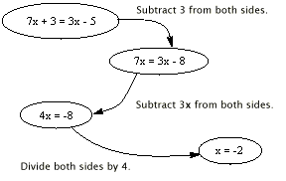47.
48. One could begin by subtracting 3x from both sides, adding 5 to both sides, or dividing both sides by 4. Moreover, there are numerous less productive steps.
49.
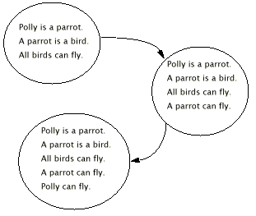50. We normally use the closed-world assumption and assume that a bird can fly unless we know otherwise.
51. Is it a law for a new tax or a new law for an existing tax?
52. The state of being in a particular city is a state of the production system. The productions are the processes by which one moves from one city to another.
53. The states would be the various sets of tasks completed. Thus, the state graph would be the following:
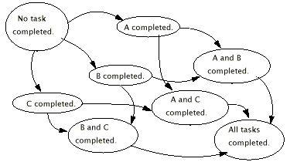
54.
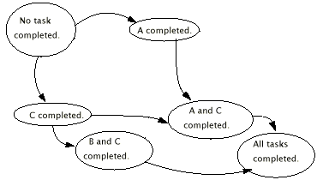

55. a. The second—which is actually the bubble sort algorithm.
b. Start with a large number of strings of pairs of integers in the range of one to ten. Test each string to see how well it sorts lists. Then, pick the best performers, cut each into two pieces, and reconnect the pieces to form another generation of potential sorting programs. Then repeat this process until a good sorting program is found.
56. The experiments may progress as follows: Try different sensor placements to see which perform the best. Then, analyze the findings to learn what works and what does not. Then experiment with new improved designs.
57. Answers will vary. The point is for the student to consider the distinction between and the roles for reactive and plan-based responses.

